MODULE 6 — COPY INTO (LOADING DATA)
33. Load CSV data from a stage into a table using COPY INTO.
create or replace stage my_internal_stage;
create or replace table employees;
PUT ‘file: employees.csv’
COPY INTO EMPLOYEES
FROM @my_internal_stage/employees.csv
FILE_FORMAT = my_csv_format
ON_ERROR = 'CONTINUE';
MEANING: It takes the csv file from the my_internal_stage and put it in the employees table.
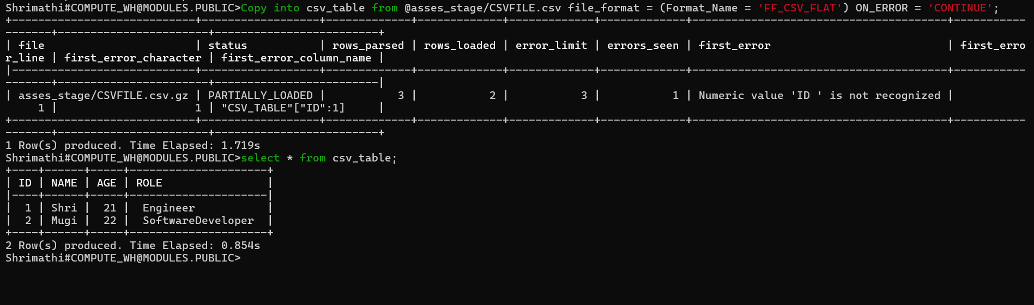
34. Load JSON file into a VARIANT table using COPY INTO.
create or replace stage my_internal_stage1;
CREATE OR REPLACE TABLE json_table (
Raw VARIANT
);
PUT ‘file://C/ employees.json’ @my_internal_stage1;
COPY INTO json_table
FROM @my_internal_stage1/employees.json/
FILE_FORMAT = (TYPE = 'JSON')
ON_ERROR = 'CONTINUE';
MEANING: It creates a table with variant..then loaded the json file in stage after, load the json file into variant table using copy into.
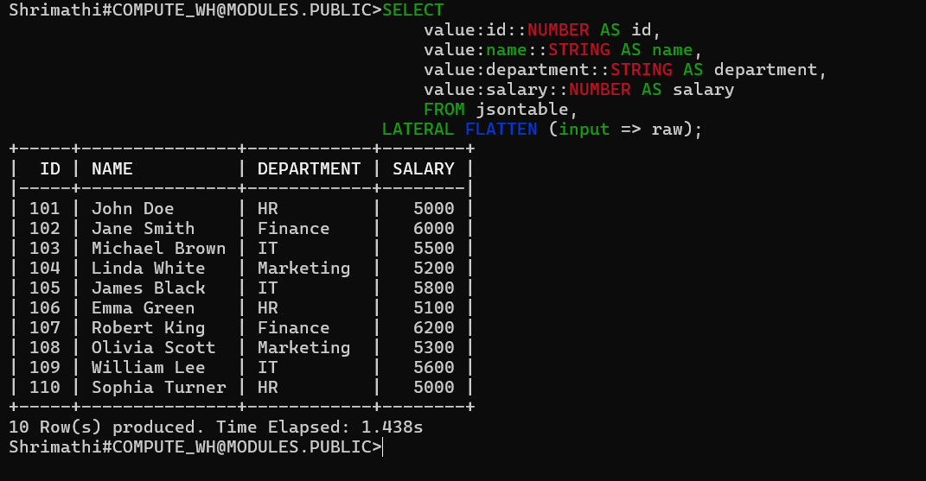
35. Load XML data using COPY INTO (file format XML).
create or replace stage my_internal_stage;
CREATE OR REPLACE TABLE xml_table (
xml_data VARIANT
);
CREATE OR REPLACE FILE FORMAT my_xml_format
TYPE = 'XML';
PUT ‘file://C/employees.xml’ @my_internal_stage;
COPY INTO xml_table
FROM @my_internal_stage/employees.xml
FILE_FORMAT = my_xml_format;
CREATE OR REPLACE TABLE employees_table ( ID INT,
NAME STRING, DEPARTMENT STRING,
SALARY INT
);
INSERT INTO EMPLOYEES_FINAL (ID, NAME, DEPARTMENT, SALARY) SELECT
XML_DOC:"@id"::string::int AS ID,
XMLGET(XML_DOC, 'name'):"$"::string AS NAME,
XMLGET(XML_DOC, 'department'):"$"::string AS DEPARTMENT,
XMLGET(XML_DOC, 'salary'):"$"::int AS SALARY
FROM XML_TABLE;
MEANING: First need to create a stage then create a table, after upload the file into stage using put command to the stage. Then, insert into the table using copy into.
36. Load only files matching a regex pattern ".*2024.*" .
COPY INTO employee_table
FROM @my_internal_stage/file_path
FILE_FORMAT = (TYPE = 'CSV')
PATTERN = '.*2024.*';
MEANING: In this ,the pattern performs to loads only files where the filename contains 2024 (EX: sales_2024_jan.csv , data_export_2024.txt).
37. Write a COPY command that skips the first 2 header lines.
COPY INTO employees
FROM @my_internal_stage/employee.csv
FILE_FORMAT = (
TYPE = 'CSV' SKIP_HEADER = 2
);
MEANING: In this, (skip header = 2) performs to skip the two header lines.
38. Write a COPY command that ignores missing columns.
COPY INTO employee_table
FROM @internal_stage/file.path
FILE_FORMAT = (
TYPE = 'CSV',
ERROR_ON_COLUMN_COUNT_MISMATCH = FALSE
)
ON_ERROR = 'CONTINUE';
MEANING: (ERROR_ON_COLUMN_COUNT_MISMATCH = FALSE) Don’t throw an error if the file has fewer columns than the table. Just fill the missing columns with NULL and continue loading.
39. Write a COPY command that loads files only from a subfolder of a stage.
COPY INTO employee_table
FROM @internal_stage/subfolder_name/
FILE_FORMAT = (TYPE = 'CSV');
MEANING: Load only the files inside one subfolder of the stage.
40. Write a COPY command that validates the file but does not load it.
COPY INTO employee_table
FROM @internal_stage/file.path
FILE_FORMAT = (TYPE = 'CSV')
VALIDATION_MODE = 'RETURN_ERRORS';
MEANING: It checks the file format, column count, invalid data, etc. It does NOT load any rows into the table. It returns only the validation results.
41. Reload a file even if Snowflake thinks it's already loaded (FORCE=TRUE).
COPY INTO emp_table
FROM @internal_stage/file.path
FILE_FORMAT = (TYPE = 'CSV')
FORCE = TRUE;
MEANING: It reloads the file again even if it was already loaded earlier.
MODULE 5 — PUT & GET COMMANDS
26. Upload a file called orders.csv to an internal stage @raw_stage.
PUT file://C:/Users/Admin/Documents/orders.csv @raw_stage;
MEANING: Upload a file (orders.csv) to an internal stage @raw_stage using PUT command.
27. Upload all CSV files from / data/ files/ folder.
PUT file:///data/files/*.csv @raw_stage;
MEANING: It selects all csv files from folder and upload it in stage using PUT command.
28. Upload files but disable auto compression.
PUT file://path/to/files/* @raw_stage
AUTO_COMPRESS = FALSE;
MEANING: It uploads the file exactly as it is, without creating a .gz compressed version.
29. List all files in stage @mystage.
LIST @mystage;
MEANING: It list all files inside the stage.
30. Download all files from stage @logs to a local folder.
GET @logs file://C:/local_folder/;
MEANING: It downloads all files from a stage @logs to a local folder.
31. Write a PUT command with parallel upload disabled.
PUT file://C:/data/files/*.csv @raw_stage
PARALLEL = 1;
MEANING: Snowflake uses only one thread, so uploads happen sequentially, not in parallel.
32. Write a GET command that downloads only.json.gz files using a PATTERN.
GET @my_stage
file://C:/local_folder/
PATTERN='.*\.json\.gz';
MEANING: It selects only files that match the extension.json.gz and download using GET command.
MODULE 7 — LISTING & REMOVING STAGE FILES
42. Write a command to list stage files ordered by size.
LIST @mystage ORDER BY size DESC;
MEANING: It shows all files in the stage and sorts by size.
43. Remove a single file from stage.
REMOVE @your_stage/filename.csv;
MEANING: It removes a single file from a Snowflake stage, using REMOVE command.
44. Remove all .csv files from stage.
REMOVE @raw_stage PATTERN='.*\.csv';
MEANING: It removes all CSV files from @raw_stage, using REMOVE command.
45. Remove files larger than 5MB (using PATTERN).
1ST Method
REMOVE @your_stage PATTERN='.*[6-9]MB.*';
MEANING: If your filenames contain size info, you can go with the above method.
2nd Method
LIST @mystage;
REMOVE @mystage/filename;
MEANING: If filenames do NOT contain size information, then you can use the above method.
The only way to remove “files larger than 5MB” using PATTERN is if your filenames contain something that indicates size.
MODULE 4 — OUTPUT FORMATTING COMMANDS
18. Write a SnowSQL command to save query output into CSV.
!output file='output.csv' format=csv
SELECT * FROM your_table;
MEANING: It tells SnowSQL to save the next query result into a CSV file.
19. Save query output into JSON format.
!output file='output.json' format=json
MEANING: It tells SnowSQL to save the next query result into a JSON file.
20. Disable header in output.
!set header=off
SELECT * FROM employees;
MEANING: The output will come without column headers.
21. Change field delimiter to "|".
!set output_field_delimiter='|'
MEANING: This makes SnowSQL display each column separated by a pipe (|) symbol instead of a comma.
22. Set NULL values to appear as the string "EMPTY".
!set output_null_value='EMPTY'
MEANING: Whenever a column has a NULL value, SnowSQL will display it as EMPTY instead of blank or NULL.
23. Write a SnowSQL command to produce output in “friendly=false” mode.
!set friendly=false
MEANING: SnowSQL will not show pretty or nicely formatted tables — instead, it shows raw, simple, unformatted output that is easier for scripts and tools to read.
24. Save output to a file called results.txt.
!output file='results.txt'
MEANING: This starts saving the next query result into results.txt. It means SnowSQL will write your next query’s output into a file named results.txt instead of showing it on the screen.
25. Format the output as tab-separated.
!set output_field_delimiter='\t'
MEANING: It means SnowSQL will separate each column using a TAB space instead of commas or other symbols.

